Marine Biology
Señor Robles
Aquatic Mammals (except the Cetaceans)

# | Name | Adaptive Characteristics | Illustration
1. | WATER BUFFALO  (related to the African cape buffalo, but not at all to the American bison.) |  | 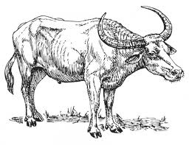
2. | CAPYBARA |  | 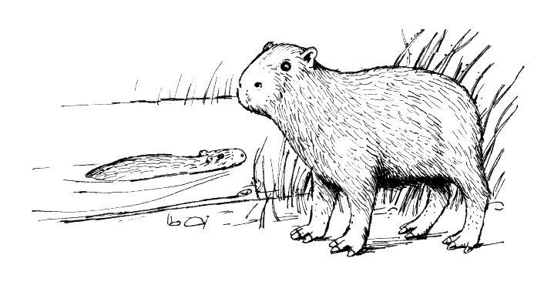
3. | PACIFIC WATER SHREW
4. | MINK |  | 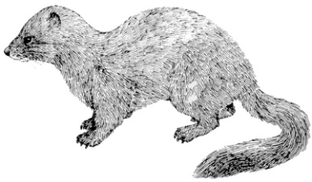
5. | MUSKRAT |  | 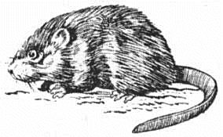
6. | BEAVER |  | 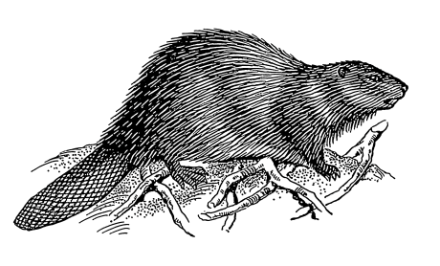

# | Name | Adaptive Characteristics | Illustration
7. | HIPPOPOTAMUS
8. | DUCK-BILLED PLATYPUS |  | 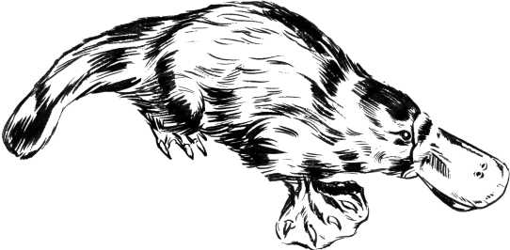
9. | SEA OTTER |  | 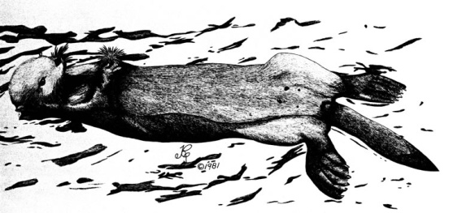
10. | STELLER SEA LION |  | 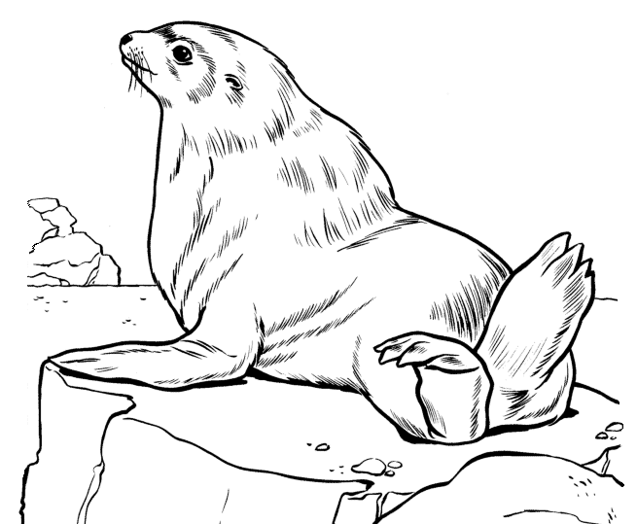
11. | HARP SEAL |  | 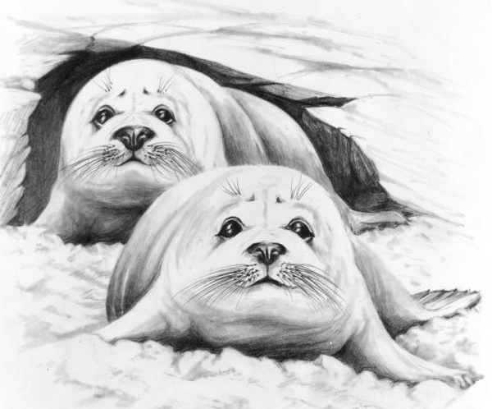
12. | MANATEE (on left)  &  DUGONG (on right) |  | 