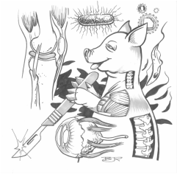
Full Name:
Biomedical Science
Señor Robles

Period:

Biomedical Science/ A & P
Class Syllabus 2019-20
Welcome to your first college class!

College Course Number: BIOL108 College Course Title: Human Biology

High School Course Title: Biomedical Science/ Anatomy & Physiology College Credits: Six

Instructor: Bryan Robles E-mail: roblesb@issaquah.wednet.edu Date: September 2019-June 2020

High School: Issaquah High School Phone: (425) 837-6063

College in the High School (CHS) is a dual credit, concurrent enrollment program. Students complete their high school graduation requirements at the same time they earn college credit. Grades earned will be entered on a high school transcript as well as on a Bellevue College (BC) transcript, indicating completion of a rigorous college class. CHS students are able to access college resources such as the library, academic tutoring and computer labs, just as any other BC on-campus students. Students will have an opportunity to complete an electronic end-of-term student course evaluation for each CHS class.
Course Description: Overview of human body functions, including and introduction to some anatomy and physiology, nutrition and exercise and modern medical advances. This course is intended for non-science majors. Course includes a laboratory. Fulfills laboratory science course requirements at BC.

Textbook:
You will have a textbook to use in class called The Human Body in Health & Disease. They will be numbered, and you are to use the one that corresponds to your desk number.

Course Outcomes
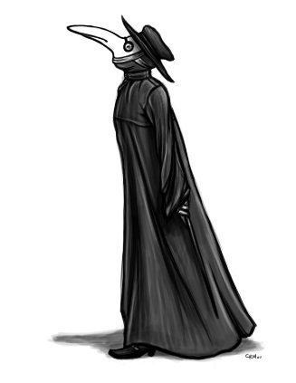
After completing this class, students should be able to:
- Identify major organ systems
- Explain the major interactions of organ systems
- Describe how your body functions
- Describe the role of nutrition and exercise in human health
- Understand selected diseases, ailments, and pathogens
- List modern medical advances
- Understand the workings of the human body within the context of the Animal Kingdom

Course Outline:
The class is divided into ten units that roughly correspond to the ten months you are in school (although the June unit is much shorter.) Each unit focuses on a particular body system, but will sometimes include other topics.

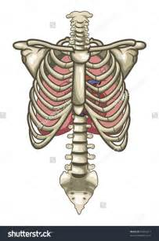
Unit System Chapter(s)
1 | Preliminaries (selected topics) | 1-6
2 | Integumentary | 7
3 | Skeletal & Muscular | 8-9
4 | Nervous & Senses | 10-11
5 | Endocrine | 12
6 | Cardiovascular & Lymphatic | 13-16
7 | Respiratory | 17
8 | Digestive | 18-19
9 | Urinary | 20-22
10 | Reproductive | 23-24

Course Expectations:
Enrolled CHS students have the same rights and responsibilities of all Bellevue College students. Additionally, CHS students’ privacy is covered under the Family Educational Rights and Privacy Act (FERPA). Please see “Frequently Asked Questions” on the CHS website www.edcc.edu/collegeinthehighschool for more important information.

Bellevue College students shall demonstrate academic integrity. It is required that all violations of academic integrity (cheating and plagiarism) be reported to the College. The College’s database of such incidents will be monitored by the Office of the Vice President for Student Services. Data will be maintained for three years. Evidence of repeat incidents will result in additional action by the Office of the Vice President for Student Services as governed by the Student Code of Conduct. In this class, cheating and plagiarism may result in loss of credit for the assignment with no possibility of make-up. If a student has two strikes in the same class, the student may lose credit for the class.

Additional Rules:
- Keep the room clean. No food or drinks at the lab tables.
- Be aware of all the safety rules, and conduct yourself accordingly.
- Cell phones are to be parked at the beginning of the period. There are times you may use your phone for taking pictures or for going online, but you need to get permission.
- Please be on time. Three or more tardies per semester will earn you detention.
- Participation points (10/quarter) if you engage in class discussions, answer questions reasonably
- Be aware of the late work policy:
___If you are absent and can’t help turning something in past its due date, write “ABSENT” on
the paper, along with the date you were missing.
___Late work (not due to absence) is worth 50%
___Overly late work (a week or more past the assigned date) will not be accepted

Assessments:
Fridays will be quiz or test days. Quizzes are taken on an app called Socrative Student, and are multiple choice. In addition, unit tests are given upon completion of a unit. These involve identification diagrams, multiple choice, T&F, and short answer type questions. Students to drop their lowest Socrative quiz at the end of each semester.

Grading Policy:
Percentage breakdown

Quizzes & tests….………60
Labwork…..…......……....20
Semester Final………..…10
Homework………………..5
Participation……………...5

Grading Scale in %
A 93 or higher
A- 90-92.99
B+ 87-89.99
B 83-86.99
B- 80-82.99
C+ 77-79.99
C 73-76.99
C- 70-72.99
D+ 67-69.99
D 60-66.99
F 0-59.99

Regular class assignments will be graded in class and recorded, but do not factor into your letter grade. They will receive a “3” if complete and on time, and a “2” or “1” if incomplete, late, or both.

This syllabus will be posted on my website, The Roblesite: http://theroblesite.weebly.com/

So, feel free to detach this sheet, sign below, and turn this page in.
Keep the first page for the entire year.

Please provide signatures below:

Student: _______________________________________ Per: ____________

Parent/guardian: _________________________________ Date: ________________

