Biomedical Science

Señor Robles

**Brain Anatomy**

*Practice Practice Practice*

Using your NON-electronic resources (journal, textbook, dissection binder) label all the boxes.

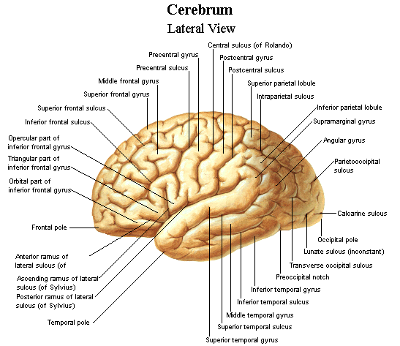

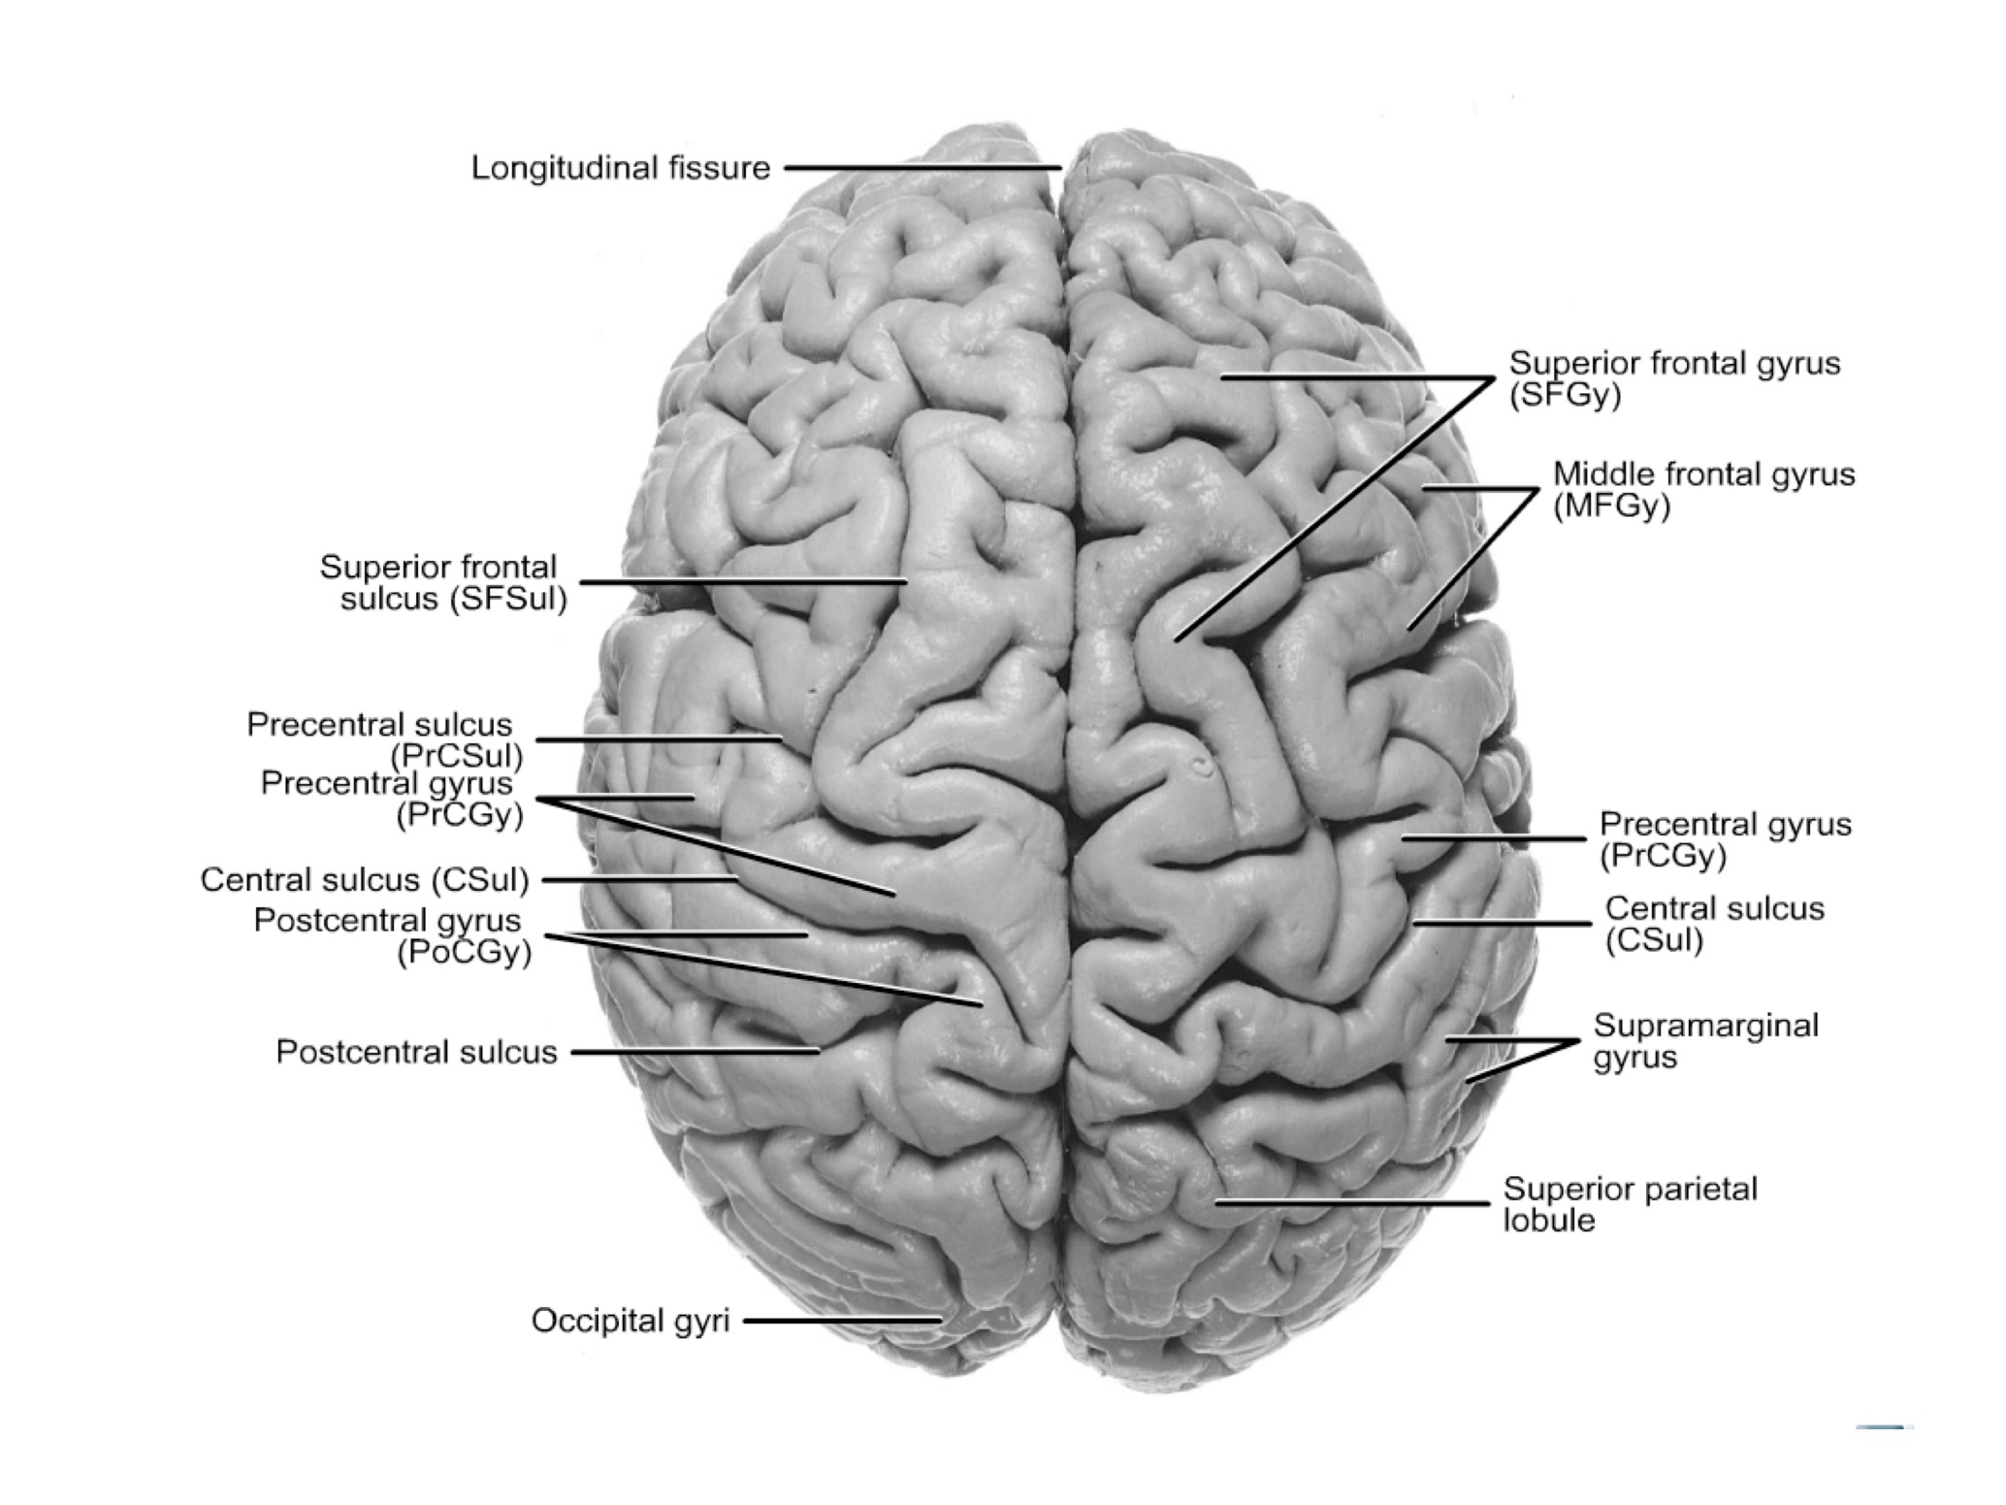

**THIS IS A DORSAL VIEW**

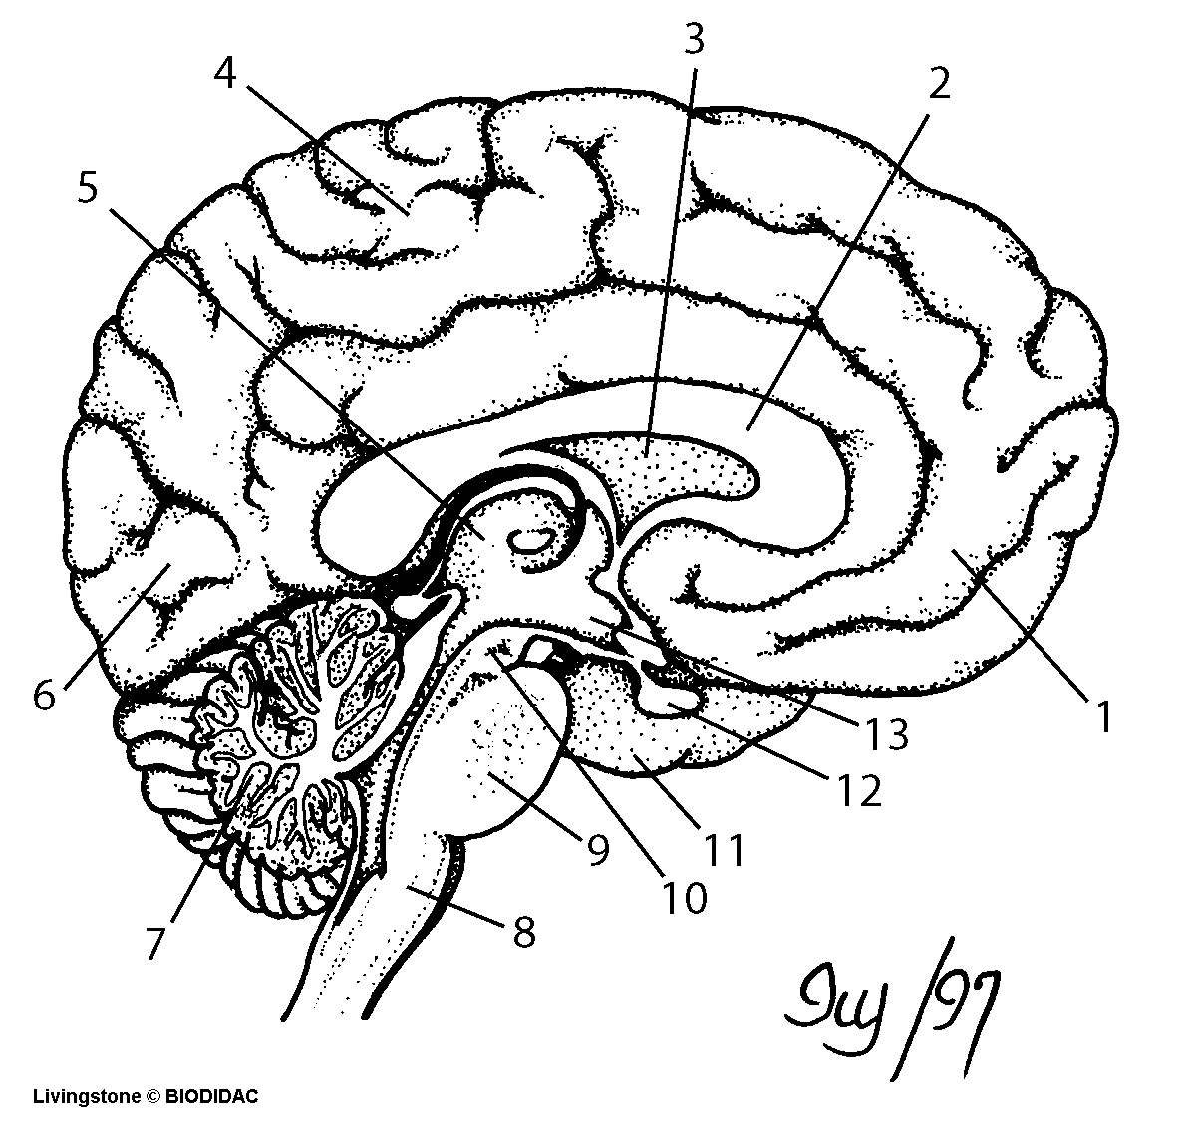

**WHAT SORT OF CUT MADE THIS VIEW?**

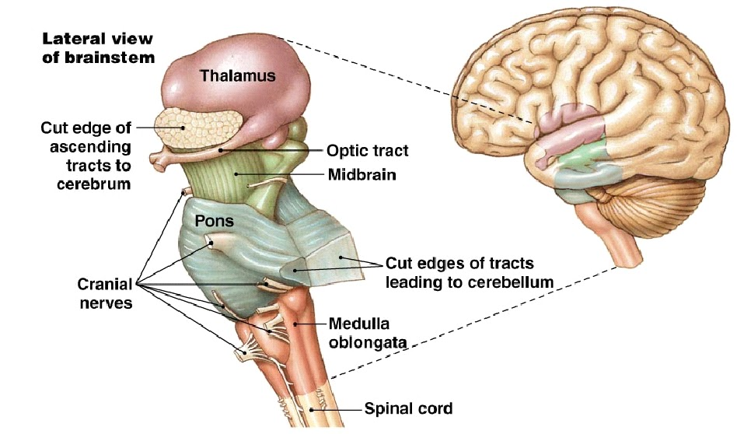

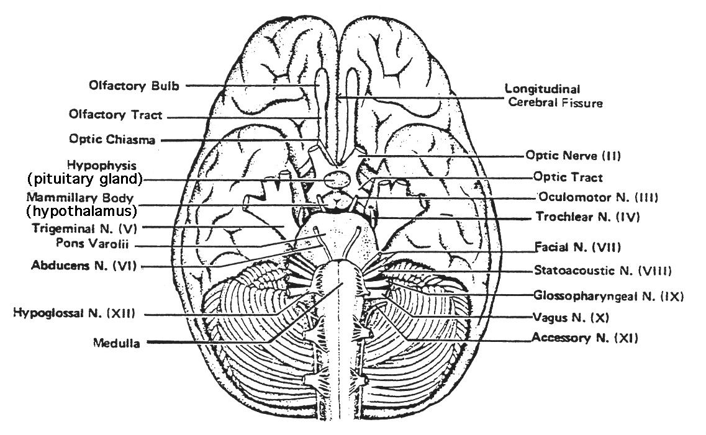

**THIS IS A VENTRAL VIEW**