BioMed
Señor Robles
Brain “quiz”

Part One. Label the following on the diagrams below:

ARBOR VITAE
CORPUS CALLOSUM
PONS
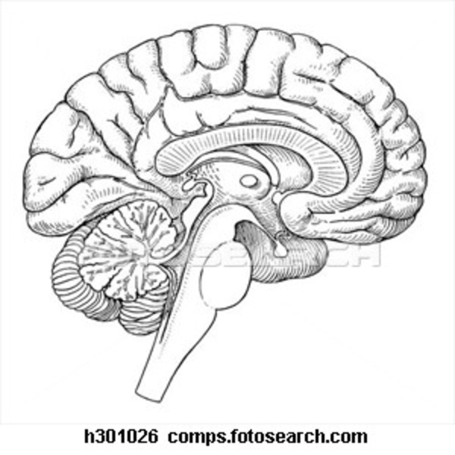
PITUITARY GLAND
SEPTUM PELLUCIDUM
MEDULLA OBLONGATA
FRONTAL LOBE
TEMPORAL LOBE
THALAMUS
CENTRAL SULCUS

Part Two (10) Miscellaneous Brain multiple choice

1. Circulating throughout the ventricles of the brain is this liquid:
a. blood b. oxygen c. CSF d. lymph

2. Bundle of white matter that joins the two brain hemispheres together
a. pons b. midbrain c. septum pellucidum d. corpus callosum

3. Ability of the brain to compensate for damaged areas.
a. plasticity b. regeneration c. regrowth d. cerebral hemorrage

4. “Emotional brain” system that was liberated in Phineas Gage, as demonstrated by his negative change in behavior
a. hippocampus b. amygdala c. limbic system d. striatum

5. Collective term for the portion of the brain that encompasses the midbrain, pons, and medulla oblongata
a. frontal cortex b. parietal lobe c. brain stem d. corpus callosum

6. Regulates sleep, hunger, thirst, body temperature, blood pressure, and fluid level to maintain homeostasis
a. thalamus b. amygdala c. medulla d. hypothalamus

7. A relay station for info coming from the spinal cord to the cerebrum, or between the cerebrum and cerebellum
a. pons b. midbrain c. septum pellucidum d. corpus callosum

8. What does the cerebral aqueduct connect?
a. the anterior horn to the posterior horn b. the third and fourth ventricles
c. the two lateral ventricles d. fourth ventricle to the central canal of the spinal cord

9. Responsible for involuntary functions such as breathing and the beating of your heart
a. pons b. midbrain c. medulla oblongata d. corpus callosum

10. What was one aspect of his Phineas Gage’s personality that changed as a result of his accident?
a. He became even more responsible b. psychic abilities c. veganism d. use of profanity

