BioMed
Señor Robles

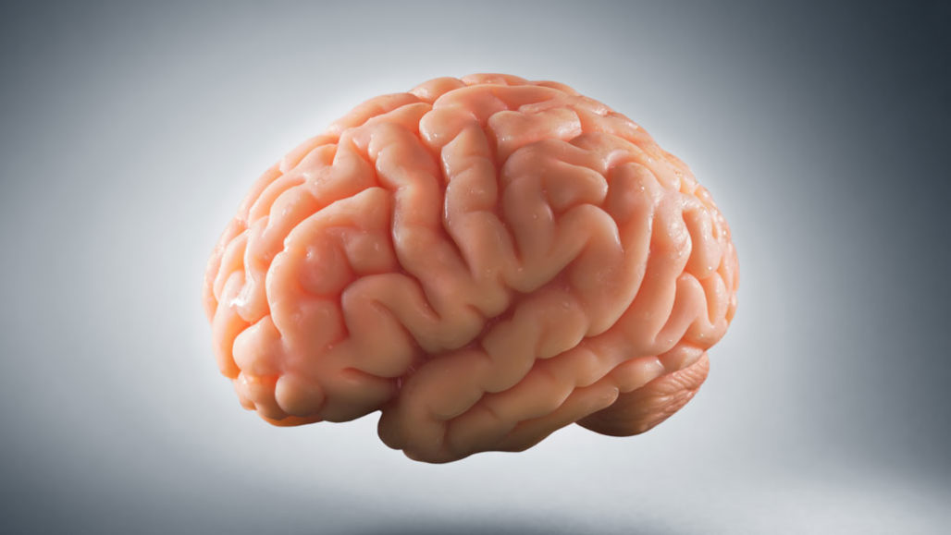

Nova Science Now
How Smart Can we Get?

This documentary is divided into five parts:

1. Einstein’s Brain
2. Memory Techniques
3. Problem Solving
4. Savant Syndrome
5. Exam Taking

Your assignment is to:

A. Watch the entire video.

B. Decide which of the five parts was most interesting to you.

C. Write a paragraph summarizing and reflecting on just that one part of the video.

Within your paragraph, make sure you address the following items (if they apply):
- What is the overall question being addressed in this section of the video?
- Who was involved in the research of this question (name & specialty)?
- Who were the subjects (individuals that demonstrated this particular brain function)?
- What portion(s) of the brain is operating / damaged for this function?
- What equipment was used in the research?
- Why you liked this particular segment.

Practice your writing skills. This is NOT a bullet point by bullet point response to the above questions. In fact, they don’t have to be addressed in the order given above. Make it an actual (enjoyable to read) paragraph that your latest English teacher would be proud of. You decide how long it should be.

Due tomorrow, anytime. You can just type it below (“on the back”).

