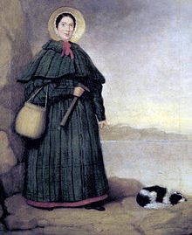
Marine Biology
Señor Robles

Mary Anning & the Mesozoic Marine Reptiles
Historic Fossil Collector & Prehistoric Giants

1. When and where was Mary born?

2. Two traumatic events occurred in her early life. Explain them:

a.

b.

3. Because of financial circumstances, Mary had to pitch in to help the family. Describe her self-appointed job.

4. Of course, any discussion of Mary Anning has to include the famous tongue twister that she inspired.
How’s it go?

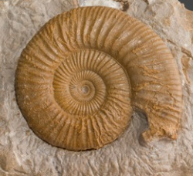
5. What are the “shells” of this tongue twister?

6. Describe the geological setting of her excursions:
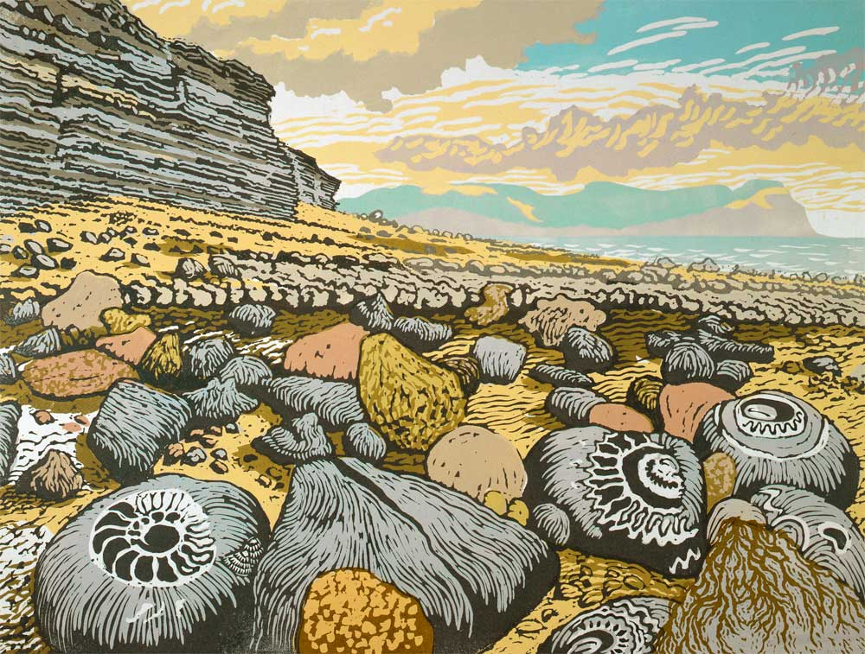
a. What is the name of the area?

b. What age (era and period) does it represent?

c. How old are the rocks?

d. What type of rock is it?
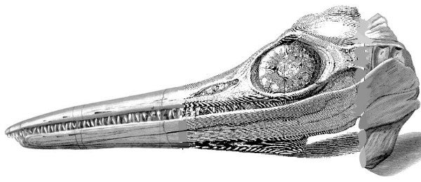
7. What was the first of the Mesozoic Reptiles she discovered? How was it mysterious?

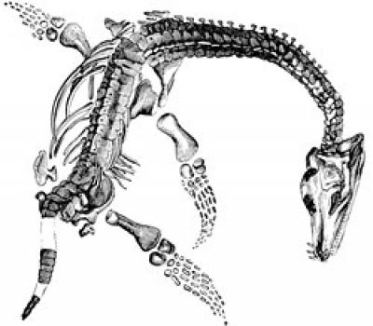
8. Describe the second of the Mesozoic Reptiles:

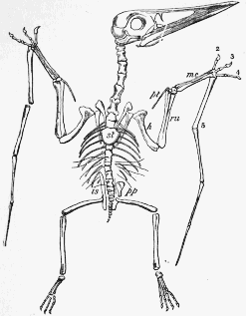
9. What about a third Mesozoic Reptile? (Perhaps already known)

10. What were the two major challenges regarding Mary and her discoveries? (One challenge that she faced, and one
challenge that her discoveries created)?

a.

b.

TRIVIA POINTS

What’s wrong with this picture? What famous artist drew this picture?
