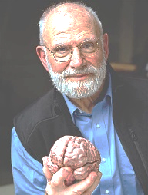
BioMed
Señor Robles

Neuropathological Studies by Oliver Sacks

Name of syndrome/condition Description of the condition Resource/link

