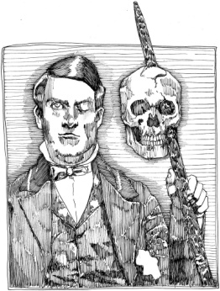
Biomedical Science
Señor Robles

Phineas Gage and the Human Brain

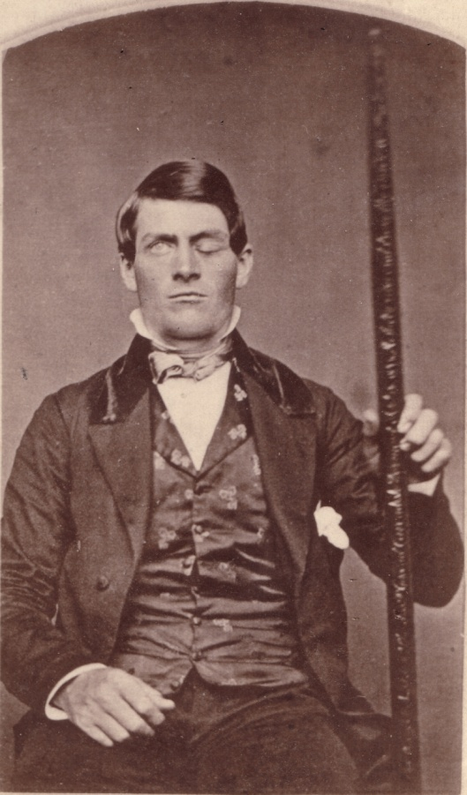
1. Briefly describe the famous accident of Phineas Gage. Include the
mysterious object he’s holding in the photo. Also, why does he seem to be
winking at you?

2. Describe Gage’s personality before the accident. What was his occupation? Did he perform his duties well?

3. What two areas of the brain were affected by this accident? Also, what are the functions of these areas?

a.

b.

4. Why did Gage experience surprisingly little pain? (What are the brain’s natural painkillers?)

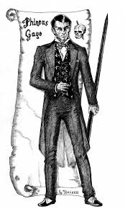

5. Describe Gage’s behavior and personality after the accident. How had it changed?

6. Did he get his old job back? Why or why not?

7. What impact did this accident and its documentation have on what we know today about the nature of the brain? In
other words, why is this old incident still relevant today?

8. Where are the remains of his famous skull now? Why is it there?

9. In your opinion, what was the most shocking part of this story?

10. Are there any “modern Phineas Gage’s?” If so, describe:

