Biomedical Science
Señor Robles
Respiratory System Illustration

First, go online and look over various diagrams that show the respiratory system.
This one is okay, but it doesn’t include the sinuses nor the branching subdivisions of the bronchus (namely the bronchioles.) It also lacks color.
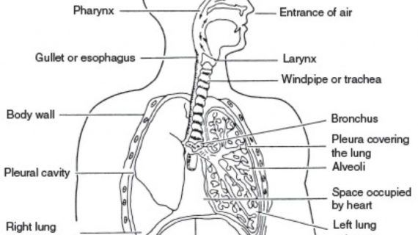

This next one is nice and clear. But the artist thinks the patient has two left lungs!
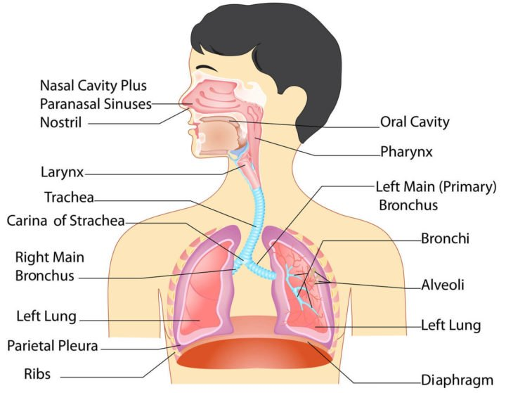

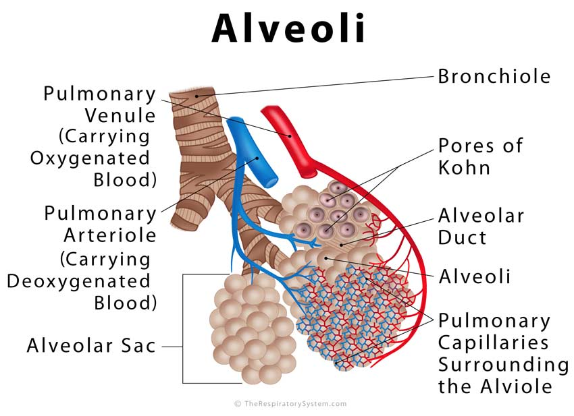
That’s why you need to look at a variety, and then combine all their good qualities. You also need to find reference illustrations for the alveoli—the little air sacs in the lung where the actual gas exchange, and the oxidation of blood, take place.

Ultimately you need to combine everything into a single illustration, one that shows the overall macroscopic view of the respiratory system, as well as the functional units of respiration (the alveoli.) This artist did it pretty well, even using an REA to show the relationship.
This illustration, however, leaves out a lot of detail.
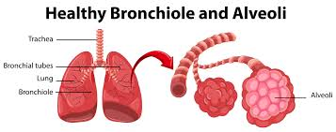

Your job is to study a variety of online diagrams, and then combine everything into one detailed illustration, with everything labeled. Normally this would go into your journal, but since I have some of them, just do it on a separate paper and we’ll attach it later.

