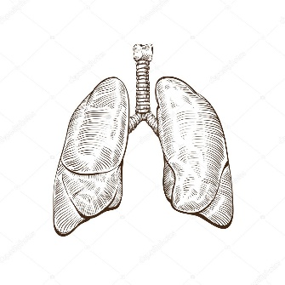
Biomed
Señor Robles

Respiratory System
Anatomy & Physiology questions

1. How is the right lung structurally different from the left lung? (Use a simple illustration to describe.)

2. What do you call the empty space in which the lungs rest?

3. What thin membrane lies between the lungs and the ribs that surround them? (It covers the lungs.)

4. The lungs work closely with a structure in your neck that’s involved in speech. What is this structure called (three possible names),
and what does it do?
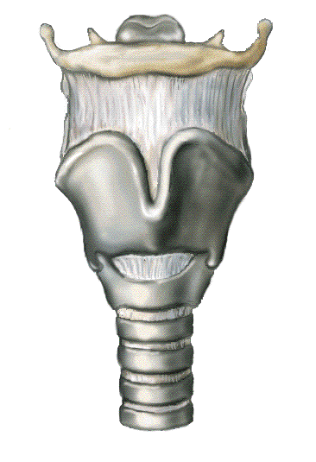
a.

b.

5. Describe the overall structure of the trachea/windpipe before it branches.

6. What type of tissue coats the inner lining of the trachea (think back to our histology unit.)

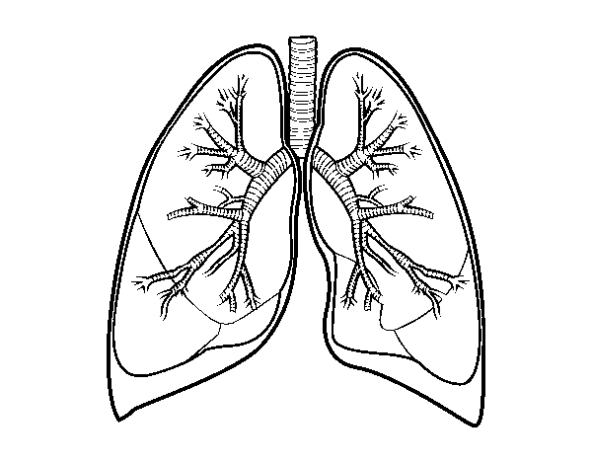
7. As the trachea leads to the lungs, it subdivides into two bronchi to enter each lung (the primary right bronchus and the primary left
bronchus.) What do you call the next two subdivisions of each bronchus? (point to them)

a.

b.

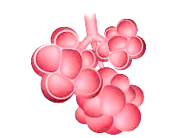
8. After all the branching, what are the microscopic “bubbles” that all
the branches terminate in?

9. Describe the action of the diaphragm muscle. When it contracts, what actually happens to enable the act of breathing?

10. Overall, what is the basic purpose of breathing?

