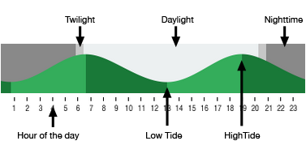
Marine Biology
Señor Robles

Tide Chart Reading

To start, find an online Tide Table. Let’s just use https://www.tides.net/washington/ (Washington Tides Tables & Charts)

Part One
I’m going to give you a couple of scenarios, and your job is to use the tide table to find the information to
fill in the below table.

# | Scenario | Best date (between April 28-30) | Tide level
1. | I want to go clam digging, and I hear it’s best to go during low tide. I guess a good place would be Clam Bay which is listed under Rich Passage on the Washington Tides chart. I need to go during daylight hours sometime in the remaining days of April. When is the lowest tide?
2. | I want to take my boat out by the Tacoma Narrows Bridge. But now I want the highest tide. Again it has to be daylight within the last three days of April. When should I go, and how high will the tide be?

Part Two
Now it’s your turn to create your own scenario, select your own location and date, and specify time & tide level:

# | Scenario | Date  (Does not have to be April. Your choice.) | Tide level

